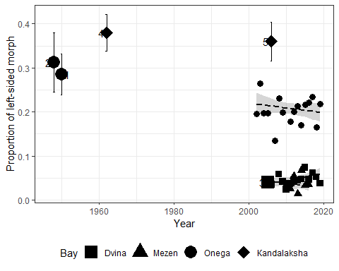

Table ++. Parameters of model fitted

|  |  |  |  |  |
| --- | --- | --- | --- | --- |
| Model term | Parameter | SE | Z-statistic | p-value |
| (Intercept) | -76.26 | 36.60 | -2.08 | 0.0372 |
| Year | 0.04 | 0.02 | 2.00 | 0.0452 |
| BayMezen | 44.52 | 122.55 | 0.36 | 0.7164 |
| BayOnega | 88.63 | 39.30 | 2.26 | 0.0241 |
| Year:BayMezen | -0.02 | 0.06 | -0.37 | 0.7139 |
| Year:BayOnega | -0.04 | 0.02 | -2.21 | 0.0268 |